## **DESIGN PEG 1 INFORMATION**

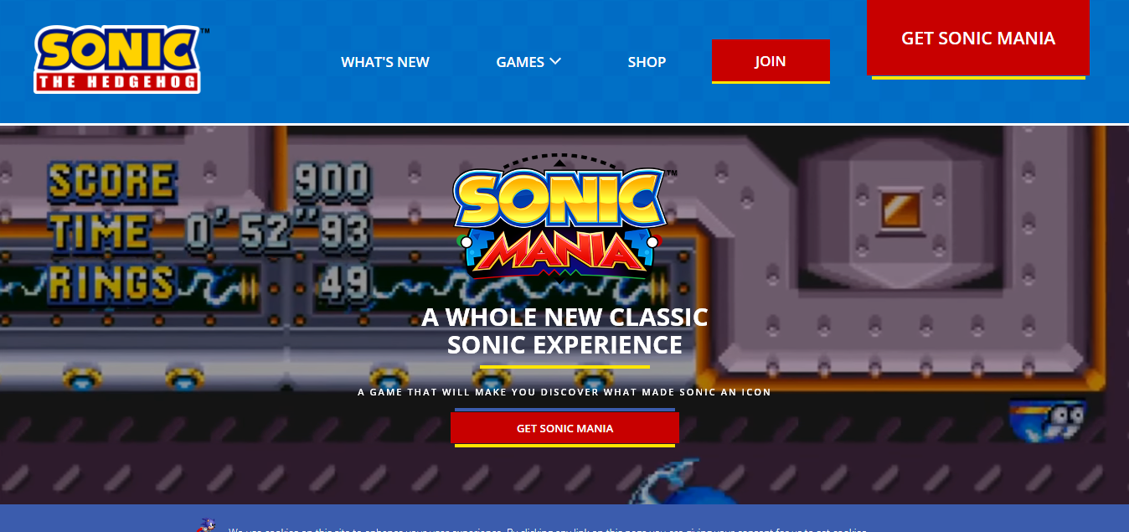



|  |  |  |
| --- | --- | --- |
| Title/Name: | Creator/ Author/ Copyright Owner: | Source: |
| Sonic Mania | SEGA | https://www.sonicthehedgehog.com/sonic-mania |

***>> PEG DESCRIPTION***

The official website of the recently released game “Sonic Mania”. Both images are in one page. However, clicking the “Get Sonic Mania” will scroll the page down to the digital download section of the page.

***>> DISCUSS THE SPECIFIC ELEMENT YOU ARE PEGGING***

The layout of the whole page and the layout of the second image where there is a big image of the character on the left and the info-text on the right.

***>> RELATION OF THE PEG TO YOUR PROJECT/HOW IS THIS PEG A REFERENCE TO A PARTICULAR ELEMENT OF YOUR PROJECT?***

Since the website will contain information about video games, the layout of the whole page is suitable for this cause. The second image also shows how the website can be presented in such a way.

## **DESIGN PEG 2 INFORMATION**

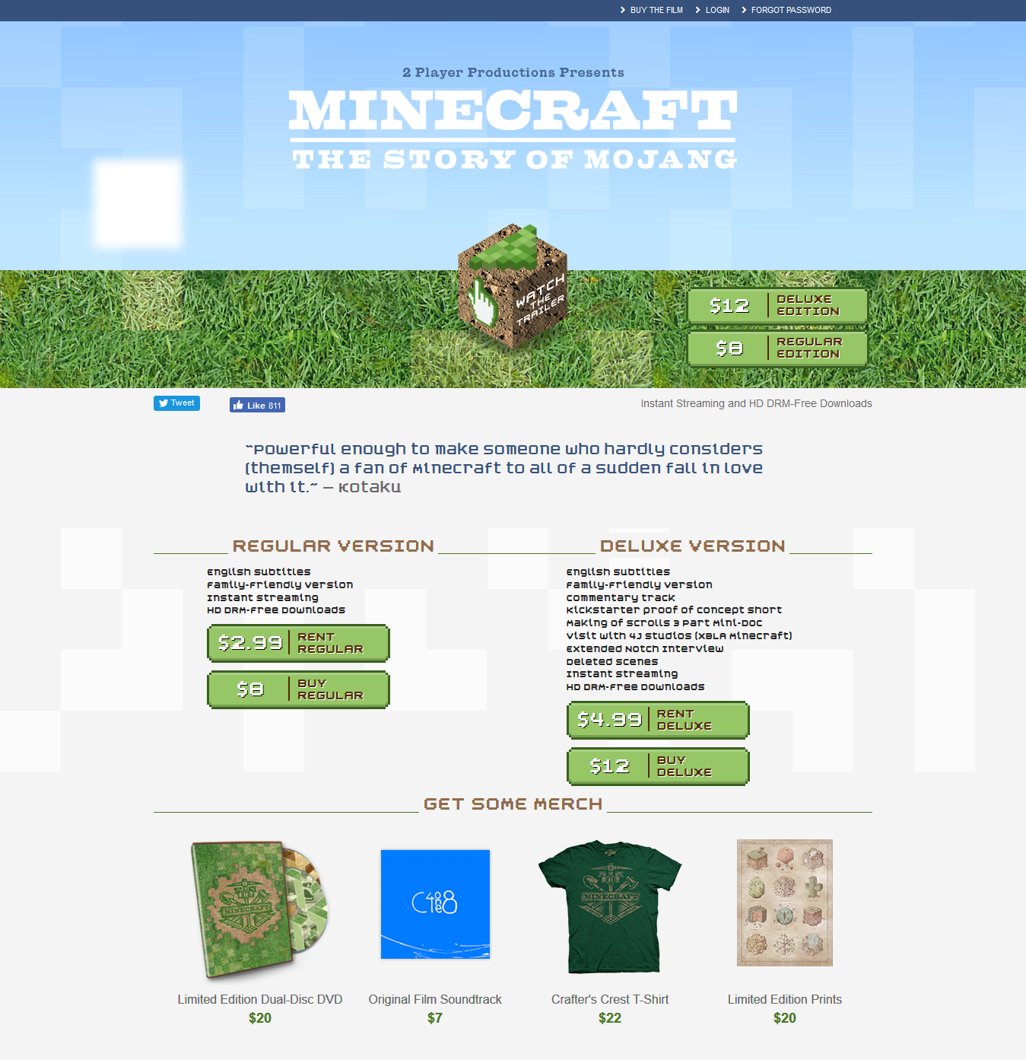

|  |  |  |
| --- | --- | --- |
| Title/Name: | Creator/ Author/ Copyright Owner: | Source: |
| Minecraft: The Story of Mojang | Jon Kay | http://www.minecraftstoryofmojang.com/ |

***>> PEG DESCRIPTION***

The official promotional website of the movie “Minecraft: The Story Of Mojang”.

***>> DISCUSS THE SPECIFIC ELEMENT YOU ARE PEGGING***

The website’s layout as it also involves merch and social media links.

***>> RELATION OF THE PEG TO YOUR PROJECT/HOW IS THIS PEG A REFERENCE TO A PARTICULAR ELEMENT OF YOUR PROJECT?***

The website’s layout is something to consider when making this website. It can be a home page and images will link to another page with another layout.

## **DESIGN PEG 3 INFORMATION**



|  |  |  |
| --- | --- | --- |
| Title/Name: | Creator/ Author/ Copyright Owner: | Source: |
| Free Minimalist Wallpaper | Unknown | https://wallpaperscraft.com/wallpaper/  minimalism_sky_clouds_sun_mountains_lake_landscape_95458 |

***>> PEG DESCRIPTION***

A random vector wallpaper.

***>> DISCUSS THE SPECIFIC ELEMENT YOU ARE PEGGING***

The image’s vector art design. It is simple so it does not distract the eye.

***>> RELATION OF THE PEG TO YOUR PROJECT/HOW IS THIS PEG A REFERENCE TO A PARTICULAR ELEMENT OF YOUR PROJECT?***

This could be possible background designs for the website to retain the focus and attention of the user.